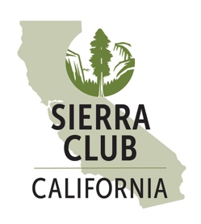
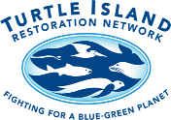
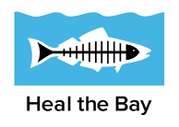
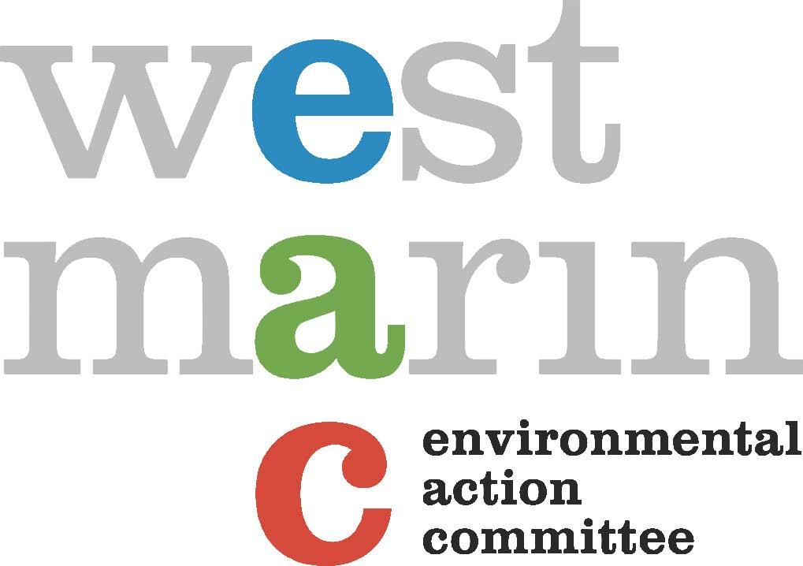
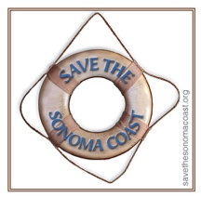

December 19, 2022
Ms. Jenn Eckerle
Acting Executive Director and Deputy Secretary for Oceans
Ocean Protection Council
715 P Street, 20th Floor
Sacramento, CA 95814
Via Electronic Mail
Re: Aquaculture Guiding Principles and Draft Aquaculture Action Plan
Dear Ms. Eckerle,
We, the undersigned organizations, have extensive experience in marine and aquaculture science and policy in the state of California. Several of our groups are also participating in the state’s development of public interest aquaculture criteria led by the California Fish and Game Commission and Department of Fish and Wildlife. And some of our organizations participated in the working group (now dissolved) and listening sessions organized by the National Center for Ecological Analysis and Synthesis related to the forthcoming Aquaculture Action Plan.
We appreciate the June 2021 Guiding Principles for Sustainable Marine Aquaculture in California (principles) put forward by the Ocean Protection Council (OPC) in collaboration with other California state agencies. While we agree with much of the content of the principles, including using a precautionary approach, the OPC’s aquaculture principles were never released for public review and do not recognize or address the full range of known ecological impacts of aquaculture. We suggest they could have benefited from input from conservation organizations and other stakeholders.
We believe any set of aquaculture principles for sustainability must acknowledge the known and/or potential impacts of aquaculture on the marine environment, habitats, wild fisheries, public health, and wildlife. Many of these impacts simply cannot be effectively managed through oversight and industry collaboration, as even best practices can be harmful to marine ecosystems. For each identified impact, the principles should describe the approach for addressing and minimizing such impacts and provide sideboards on the types of impacts that are unacceptable. As such, we note several impacts that are not identified in the OPC’s principles and propose additional safeguards in the principles to ensure sustainability more explicitly. We are glad to see the principles omit marine finfish aquaculture and hope to see the forthcoming Aquaculture Action Plan expressly exclude marine finfish aquaculture.
We ask that the OPC carefully consider these comments in future revisions of the aquaculture principles and in the forthcoming Aquaculture Action Plan.
Specifically, we propose the OPC more explicitly identify and address marine aquaculture impacts as detailed in the below table:
Known and Potential Impacts of Marine Aquaculture | Proposed Principles/Approaches to Avoid or Minimize Harm
Escapes:, Farmed species introduced into the natural environment. This can be ongoing leakage and/or major events through breaches in nets, cages, or ponds due to human error or natural catastrophes. Except in rare cases such as fully closed systems, escapes should be assumed to be inevitable.  - For native species: may impact the genetics of wild, native marine species.  - For non-native species: may compete with and/or displace wild species. | Native species are generally preferred over non-native species.  Any native species should be genetically identical to wild stocks, with no more than 2 generations separation between wild stocks and grow-out (“F2”).  No species known to be or that may be invasive may be allowed.  No non-native species may be grown unless they have a long-term track record showing they do not reproduce or establish in the system they are grown, do not interbreed with wild stocks, and/or will not experience an increase in wild reproduction under warmer ocean conditions or other climate-related ocean changes.  No genetically engineered species should be permitted.
Disease/Parasites/Pathogens: Incubation and spread of diseases, parasites, and pathogens to wild populations. | In addition to requiring robust management measures to prevent disease outbreaks, no aquaculture operations with a history of disease outbreaks shall be allowed.  Only operations using systems with a track record of disease-free operation may be considered.  Establish maximum densities of cultured organisms to prevent disease spread.
Chemicals/Antibiotics:  Use of chemicals and/or antibiotics both to prevent prophylactically and to treat bacterial infections and diseases, which may be released into marine ecosystems and contaminate wildlife. | No aquaculture operations shall be allowed that routinely use any chemicals or antibiotics.
Habitat Impacts:  - Adverse impacts to essential fish habitats, habitat areas of particular concern, marine protected areas (MPAs), and other sensitive habitats.  - Aquaculture can harm eelgrass through propeller cuts and shading, among other impacts. Eelgrass habitat is also challenging to restore. Artificial physical structures in eelgrass prevent certain species from utilizing such habitat. | No aquaculture shall be sited in areas containing eelgrass,, or inside or adjacent to state MPAs. At a minimum, no aquaculture shall be sited inside or adjacent to MPAs, where aquaculture is prohibited.  Support for eelgrass principle and protection: As a whole, eelgrass meadows are one of the most productive and diverse marine ecosystems in the world. They are recognized globally as nursery areas for many taxa and are considered one of the most important juvenile habitats for numerous fish species, including several commercially important species.  Eelgrass meadows provide essential ecosystem structure, functions, and services. For example, eelgrass beds slow the movement of water currents and waves, protecting shorelines from erosion and promoting the settlement of suspended sediments. For this reason, they might serve as a nature-based climate adaptation solution. Eelgrass also plays a significant role in carbon sequestration. Along with other seagrasses, eelgrass beds can capture carbon from the atmosphere up to 35 times faster than tropical rainforests. While seagrasses, such as eelgrass, only make up about 0.2% of the total seafloor, they account for almost 10% of the global ocean carbon storage.  Protection and restoration of, and avoidance of impacts to, eelgrass is consistent with the OPC’s Strategic Plan goals and the California Eelgrass Mitigation Policy.
Artificial structures:  - The construction, operation, maintenance, and existence of offshore structures alter natural habitats, and may impact migrations and safe passage of sensitive wildlife species.  - Aquaculture operations can unnaturally attract predators such as seabirds, marine mammals, and sharks, resulting in the need for predator controls and deterrence that may harm these natural species.  - Displacement and harm to existing commercial and recreational fishing.  - Disruption, harm, and/or conflict with other existing human uses of the marine environment including recreational uses and public access like surfing, swimming, and boating.  - Impacts to Endangered Species Act listed species.  - Alterations or disruptions to foraging, reproduction, and migration of fish and wildlife, including seabirds, marine mammals, and sea turtles. | Impacts from structures should be required to follow the mitigation sequence, where such impacts are first avoided if possible, minimized if they cannot be avoided, or mitigated if necessary.  Prioritize the use of alternatives to plastic-based structures and materials to reduce marine debris and plastic pollution in nearshore ecosystems.  Conduct mapping of important ecological areas and fishing areas. Only site aquaculture operations in areas outside of key feeding and migratory routes for fish and marine mammals, and outside key fishing grounds.  Ensure thorough review of potential impacts to endangered or threatened species and take a precautionary approach.
Saltwater intakes (for tanks or pond systems adjacent to marine waters): Entrapment of fish and invertebrate eggs, larvae, and juveniles in water intake. | Entrapment should be avoided, minimized, or mitigated.
Discharge: Potential impacts from discharge should also be considered. For example, purple urchin ranching operations have the potential to discharge larvae into areas that do not currently have overpopulation issues, therefore impacting the health of kelp beds in the area of discharge. Other impacts include discharge of nutrients or chemicals. | Discharge impacts should be avoided, minimized, or mitigated.
Non-filter feeders (e.g., abalone): Species that require large inputs of kelp as feed, creating demand for wild kelp harvesting in the vicinity, which directly removes habitat for wild fish, invertebrates, and wildlife. | Ensure that any commercial harvest of wild kelp is conducted sustainably and is consistent with the OPC’s Strategic Plan, Interim Kelp Action Plan, and other statewide guidance.
Marine finfish:  - To date, no studies have shown marine finfish aquaculture is able to be done sustainably without significant adverse effects to the surrounding ecosystem and wildlife.  - For aquaculture species that require feeding, the use of feeds puts pressure on wild forage fish stocks and/or land-based agriculture operations that may impact marine ecosystems, destroy natural habitats, contribute to greenhouse gas emissions, and create a net loss of the global supply of edible protein.  - Uneaten feeds and waste products may impact local food webs in the water column as well as impact benthic habitats in the vicinity of aquaculture operations.  - Many purported “land-based” aquaculture systems may impact marine ecosystems. | At this time, the state shall not permit any form of marine finfish aquaculture. This is consistent with the principles and OPC Strategic Plan, Objective 4.2.  Define “marine finfish aquaculture” broadly to include any form of finfish aquaculture directly adjacent to marine waters, that uses marine or estuarine waters as intake, or discharges into marine or estuarine waters.

Additional Considerations
Focus on Ensuring Sustainability of Existing Aquaculture before Promoting Expanded Aquaculture
As an initial point, there is currently a substantial and diverse aquaculture industry in California. However, existing operations face many sustainability concerns and issues, and more work is needed to ensure proper and robust management of current operations. The Aquaculture Action Plan should prioritize securing additional management capacity to ensure the sustainability of existing operations before promoting the expansion of new operations.
Marine Planning, Siting, and Cumulative Impacts
Before siting any new aquaculture, important ecological areas must be fully identified and the capacity of the surrounding region to support additional aquaculture in terms of water quality, species impacts, and habitat area must be assessed. This should include comprehensive regional mapping and planning, including an explicit calculation at the regional scale of the maximum number and size of aquaculture operations. Even the most sustainable individual operations could still be detrimental if there are already too many operations in an area. The full suite of economic impacts both positive and negative should also be considered.
Management Partnerships
Related to reducing duplicative agency efforts as addressed in the principles, while this is logical, we must also caution against excluding any relevant agencies, as each agency typically has a unique mandate and environmental regulations that they are responsible for overseeing.

Funding
Any private, commercial, for-profit aquaculture operation is benefiting from public resources and likely impacting public trust resources, and the economic burden must be placed on operators to fund the costs of government oversight and management. It is not the responsibility of taxpayers to provide funding to support commercial aquaculture management. The existing resource agencies are likely currently underfunded and may lack capacity and/or resources to adequately handle increased applications, which needs to be addressed by shifting the financial responsibility to aquaculture operators.
Also related to funding, is the need to have appropriate funding for clean-up costs. Each aquaculture proposal should address in some way, how clean-up costs will be addressed. For instance, there must be appropriate funds available for a potential clean-up through an escrow account, financial surety, or other binding process. We also note the complexity of these issues and the importance of equity. One way to address these issues might be a grant opportunity for smaller operators who have environmentally sound and strong proposals; however, this would need additional discussion and vetting.
False or Speculative Benefits
Carbon Sequestration: Before signaling or recognizing any form of seafood-producing aquaculture can meaningfully sequester carbon, there must be clear evidence and quantification of the amount of carbon that is permanently removed from the atmosphere. Generally, aquaculture products, such as food, that re-release greenhouse gasses into the atmosphere when consumed should not be considered to have a carbon sequestration benefit. Other potential carbon sequestration benefits associated with seaweed aquaculture in particular remain an area of active research and are therefore still highly uncertain. In raising this concern, we make a distinction between commercial seaweed aquaculture and restoration projects, the latter of which we support as a climate mitigation and adaptation pathway as well as a tool for restoring wild species. We appreciate the good work that the state of California has begun around supporting blue carbon and wetland restoration projects. However, regarding commercial state water bottom leases, there is a potential for commercial structures to damage natural ecosystems, wildlife, wild fish populations, or habitats, in which case the proposals may actually harm adaptation, rather than aiding in climate resilience.
Trade Imbalance & Local Food Security: While we understand and appreciate the benefits of locally produced seafood, we urge caution around trade imbalance arguments and recommend that any data be closely reviewed before this is used as a reason for expansion of aquaculture. Misinformation around and a disconnect between what types of seafood are exported and imported can create confusion, such as with some aquaculture products that are exported for processing and re-imported for sale. For instance, it is often quoted that 90 percent of U.S. consumed seafood is imported, implying only 10 percent is of domestic origin. However, recent estimates show that a more realistic estimate of domestic seafood is closer to 35 or 38 percent, and the majority of domestically-caught seafood is exported. Regarding benefits to local food security, in order for aquaculture products to meet this objective, it should be documented that the specific product will be lower cost than other similar food sources and made widely available to underprivileged consumers or communities in close proximity to the project.
Minimum Criteria/BMPs/Project Conditions
As mentioned above, several of our groups have been actively engaged in the development of aquaculture public interest criteria. Many of our organizations have also engaged in the stalled development of best management practices (BMPs) by the Fish and Game Commission and in supporting strong coastal development permit conditions. Related to project development, there should be some understanding that certain BMPs, or conditions must be met for a project to go forward. For instance, BMPs or conditions should require quarterly clean-ups and reduction of marine debris while addressing the above impacts.
Definitions
In defining “marine aquaculture,” it is critical that any operation that is in close proximity to marine or estuarine environments, that uses marine or estuarine waters as intakes, and/or that discharges water or waste into marine/estuary environments is considered “marine aquaculture,” even if components of the operation such as tanks are located on land.
In defining “recirculating systems,” this should be limited to those fully closed systems that do not discharge any wastewater and only add water to replace water lost to evaporation.
“Conservation, regenerative, or restorative aquaculture” should be defined as having the sole purpose of seeking to replenish endangered or depleted species. This definition explicitly excludes hatcheries with the purpose of augmenting capture fisheries. There should be a distinction made between conservation and commercial aquaculture, as these two types of aquaculture have different purposes.
Public Process in Aquaculture Planning
Our organizations ask that there be a robust public engagement process associated with the development of the Aquaculture Action Plan. We are concerned that due to delays related to the release of an initial draft, there may not be adequate time for broad public input. We also suggest that an outline or scoping document could be released for initial public feedback.
We appreciate the aquaculture planning updates provided at other agency meetings and related meeting documents, such as those of the Fish and Game Commission’s Marine Resources Committee (MRC). It may also be helpful to provide updates at other agency meetings including the California Coastal Commission, as was mentioned by Mark Gold at the August California Coastal Commission meeting. Based on a written update in the November 2022 MRC meeting documents, we understand the Aquaculture Leadership Team will be convening soon as a working group if they have not already. Regular updates related to these meetings would increase public transparency. We are also interested in learning whether there will be opportunities for stakeholder participation or engagement in this working group.
Conclusion
Thank you for your consideration of our comments and your work on the principles and Aquaculture Action Plan. This is an important opportunity for the OPC to improve the management of California’s existing aquaculture portfolio and ensure that as interest in aquaculture grows, it is carefully and appropriately sited based on a review of the best available science and data. We are hopeful that many of our concerns are shared and that our goals may be compatible with current and future OPC guidance. We look forward to continued public participation on this topic, and please do not hesitate to contact us to discuss our concerns and recommendations in more detail.
Sincerely,
Chance Cutrano, Director of Programs  Resource Renewal Institute | Ashley Eagle-Gibbs, Esq., Legal & Policy Director  Environmental Action Committee of West Marin
Cea Higgins, Co-Founder  Save the Sonoma Coast | Barak Kamelgard, Senior Attorney  Los Angeles Waterkeeper
Emily Parker, Coastal & Marine Scientist  Heal the Bay | Rebecca Schwartz Lesberg, President  Coastal Policy Solutions
Geoff Shester, Ph.D., California Campaign Director & Senior Scientist  Oceana | Courtney S. Vail, Campaign Director  Oceanic Preservation Society (OPS)
Scott Webb, Advocacy & Policy Director  Turtle Island Restoration Network | Erin Woolley, Policy Advocate  Sierra Club California

cc: Noah Ben-Aderet, Sustainable Fisheries and Aquaculture Program Manager
Ocean Protection Council

Guiding Principles for Sustainable Marine Aquaculture in California. (2021). https://www.opc.ca.gov/webmaster/_media_library/2021/06/Aquaculture-Principles-Public-20210604.pdf.
Hansen, L.P., Jacobsen, J.A. and Lund, R.A. (1993). High numbers of farmed Atlantic salmon. Salmo salar L., observed in oceanic waters north of the Faroe Islands. Aquaculture Research, 24: 777-781. https://doi.org/10.1111/j.1365-2109.1993.tb00657.x.
McKindsey CW, Landry T, O’Beirn FX, Davies IM (2007) Bivalve aquaculture and exotic species: a review of ecological consideration and management issues. J Shellfish Res 26: 281–294. https://doi.org/10.2983/0730-8000(2007)26[281:BAAESA]2.0.CO;2.
Ibid.
Gharrett, A.J. et al. (1999) Outbreeding depression in hybrids between odd- and even-broodyear pink salmon. Aquaculture 173, 117–129. https://doi.org/10.1016/S0044-8486(98)00480-3.
King, N. G., Wilmes, S. B., Smyth, D., Tinker, J., Robins, P. E., Thorpe, J., Jones, L., and Malham, S. K. (2021). Climate change accelerates range expansion of the invasive non-native species, the Pacific oyster, Crassostrea gigas. ICES Journal of Marine Science, 78: 70–81. https://doi.org/10.1093/icesjms/fsaa189.
Ibid.
Bouwmeester, M.M., Goedknegt, M.A., Poulin, R., Thieltges, D.W. (2021). Collateral diseases: Aquaculture impacts on wildlife infections. J Appl Ecol. 58: 453– 464. https://doi.org/10.1111/1365-2664.13775.
Lalumera, G.M., Calamari, D., Galli, P., Castiglioni, S., Crosa, G. & Fanelli, R. 2004. Preliminary investigation on the environmental occurrence and effects of antibiotics used in aquaculture in Italy. Chemosphere, 54: 661–668. https://doi.org/10.1016/j.chemosphere.2003.08.001.
McKindsey CW, Anderson MR, Barnes P, Courtenay S, Landry T, et al. (2006) Effects of shellfish aquaculture on fish habitat. Canadian Science Advisory Secretariat, Fisheries and Oceans Canada. https://www.dfo-mpo.gc.ca/csas-sccs/publications/resdocs-docrech/2006/2006_011-eng.htm.
Tallis, H.M., Ruesink, J.L., Dumbauld, B., Hacker, S., and Wisehart, L.M. (2009). Oysters and Aquaculture Practices Affect Eelgrass Density and Productivity in a Pacific Northwest Estuary. Journal of Shellfish Research 28(2), 251–261. https://doi.org/10.2983/035.028.0207.
Everett, R., Ruiz, G., and Carlton, J.T. (1995). Effect of oyster mariculture on submerged aquatic vegetation: an experimental test in a Pacific Northwest estuary. Mar. Ecol. Prog. Ser. 125:205–217. https://doi.org/10.2983/035.028.0207.
Murphy, G. E. P. et al. (2021). From coast to coast to coast: ecology and management of seagrass ecosystems across Canada. FACETS. 6: 139–179. https://doi.org/10.1139/facets-2020-0020.
Heck Jr, K. L., Hays, G., and Orth, R. J. (2003). Critical evaluation of the nursery role hypothesis for seagrass meadows. Marine Ecology Progress Series, 253, 123–136. https://www.int-res.com/articles/meps2003/253/m253p123.pdf.
Stephens, T. (2021) Seagrass restoration study shows rapid recovery of ecosystem functions. https://news.ucsc.edu/2021/10/eelgrass-restoration.html.
Ondiviela, B. et al. (2014) The role of seagrasses in coastal protection in a changing climate. Coast Eng. 87: 158−168 https://www.sciencedirect.com/science/article/abs/pii/S0378383913001889?via%3Dihub.
Mcleod, E., et al. (2011). A blueprint for blue carbon: toward an improved understanding of the role of vegetated coastal habitats in sequestering CO2. Frontiers in Ecology and the Environment, 9(10), 552–560. https://esajournals.onlinelibrary.wiley.com/doi/full/10.1890/110004.
Fourqurean, J., Duarte, C., Kennedy, H. et al. Seagrass ecosystems as a globally significant carbon stock. Nature Geosci 5, 505–509 (2012). https://doi.org/10.1038/ngeo1477.
https://www.opc.ca.gov/webmaster/ftp/pdf/agenda_items/20200917/Item6_CEMP-Resolution-Staff-Rec.pdf.
McKindsey, C.W. (2010). Aquaculture-related physical alterations of habitat structures as ecosystem stressors. Canadian Science Advisory Secretariat. Fisheries and Oceans Canada. https://www.dfo-mpo.gc.ca/csas-sccs/Publications/ResDocs-DocRech/2010/2010_024-eng.html.
Lloyd, B.D. (2003). Potential Effects of Mussel Farming on New Zealand’s Marine Mammals and Seabirds; Department of Conservation: Wellington, New Zealand. https://www.doc.govt.nz/globalassets/documents/science-and-technical/musselfarms01.pdf.
See Ahmad, A.L., Chin, J.Y., Harun, M.H.Z.M., Low, S.C. (2022). Environmental impacts and imperative technologies towards sustainable treatment of aquaculture wastewater: A review, Journal of Water Process Engineering, Volume 46, 102553, https://doi.org/10.1016/j.jwpe.2021.102553.
Lorentsen, S.-H., Sjøtun, K., & Grémillet, D. (2010). Multi-trophic consequences of kelp harvest. Biological Conservation, 143(9), 2054–2062. https://doi.org/10.1016/j.biocon.2010.05.013.
OPC Strategic Plan. (2020). http://www.opc.ca.gov/webmaster/ftp/pdf/agenda_items/20200226/OPC-2020-2025-Strategic-Plan-FINAL-20200228.pdf.
OPC Interim Action Plan. (2021). https://www.opc.ca.gov/webmaster/ftp/pdf/agenda_items/20210216/Item7_KelpActionPlan_ExhibitA_FINAL.pdf.
See Carballeira Braña C.B., Cerbule K., Senff P. and Stolz I.K. (2021). Towards Environmental Sustainability in Marine Finfish Aquaculture. Front. Mar. Sci., 8:666662. https://www.frontiersin.org/articles/10.3389/fmars.2021.666662/full.
Ibid.
Gephart, J.A., Froehlich, H.E., and Branch, T.A. (2019). To Create Sustainable Seafood Industries, the United States Needs a Better Accounting of Imports and Exports. Proceedings of the National Academy of Sciences, 116 (19), 9142–46, https://www.pnas.org/doi/full/10.1073/pnas.1905650116.
See Global Ghost Gear Initiative. (2021). Best Practice Framework for the Management of Aquaculture Gear. Prepared by Huntington, T. of Poseidon Aquatic Resources Management Ltd. for GGGI. 81 pp. plus appendices, https://www.ghostgear.org/news/aquaculture-best-practice-framework.

